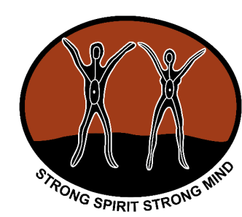

**Strong Spirit Strong Mind**

**Aboriginal Alcohol and Other Drug Awards 2023**

As part of the *2023 Western Australian Aboriginal Alcohol and other Drug Workers Forum* *Time for Action,* we would like to acknowledge the outstanding work and contributions being achieved by the sector in the Aboriginal alcohol and other drug field. The event will be held at The Westin Perth on the 18th and 19th May 2023. Opportunities to nominate an individual or an organisation for an award are now open.

There are five (5) Strong Spirit Strong Mind Award categories in 2023:

* ***WA Aboriginal alcohol and other drug worker of the year***
* ***Innovative and culturally responsive Aboriginal alcohol and other drug program***
* ***Partnership award***
* ***Organisation recognition award***
* ***Outstanding student award***

If you would like to nominate a person, program or organisation for an award, please fill in the appropriate nomination form/s and return by **Friday 10th March 2023**. Please note that late nomination forms cannot be accepted.

Detailed information on the awards and the nomination forms are provided in the attached package.

If you require further information please contact Stefanie Palmer at WANADA by emailing [stefanie.palmer@wanada.org.au](mailto:stefanie.palmer@wanada.org.au) or phone **(08)** **6557 9426.**

On behalf of WANADA and our forum reference group, we encourage you to consider nominations for these awards.

Yours sincerely

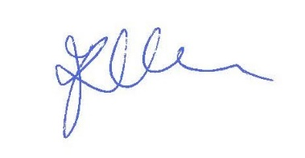

Jill Rundle

CEO

WANADA

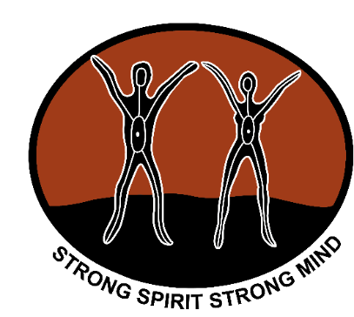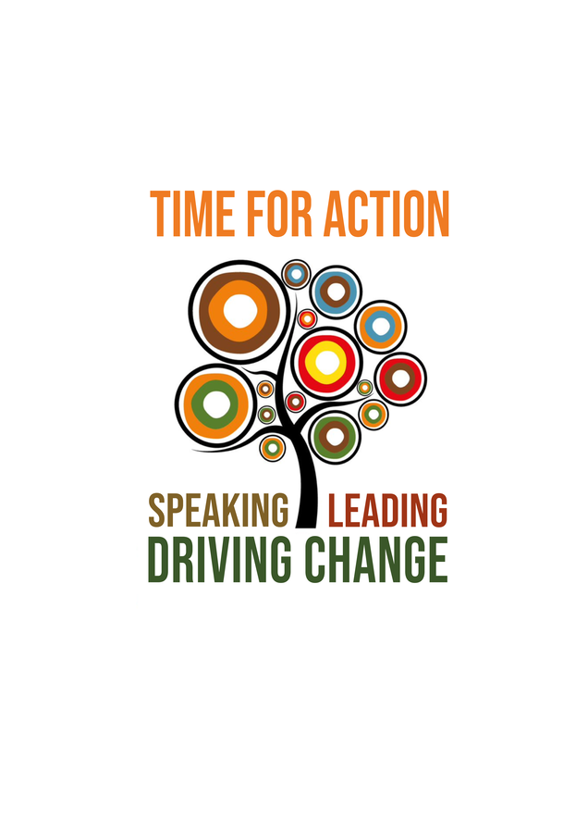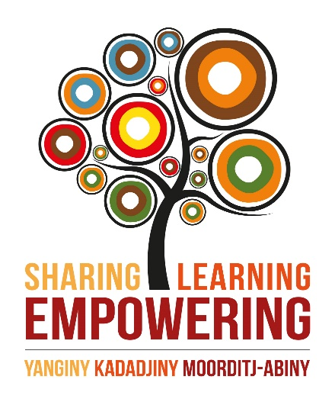

NOMINATION PACKAGE

**STRONG SPIRIT STRONG MIND**

**AWARDS 2023**

**NOMINATION PACKAGE**

This package contains:

* Contact details
* Award information
* Entry guidelines
* Nomination forms

ENQUIRIES AND RETURN NOMINATION FORMS TO:

**Stefanie Palmer**

WANADA

Email: stefanie.palmer@wanada.org.au

Phone: (08) 6557 9400

**Closing date for nominations is  
 5pm Friday 10th March 2023**

**Late nomination submissions cannot be accepted**

**AWARD INFORMATION**

AWARD INFORMATION

The purpose of the *Strong Spirit Strong Mind Aboriginal Alcohol and other Drug Awards* is to acknowledge and recognise the outstanding contributions made by organisations and individuals in the alcohol and other drug sector.

The categories of the awards are to identify individuals, projects and organisations that have made a significant improvement in the health and wellbeing of Aboriginal people affected by alcohol and other drugs.

There are five (5) Strong Spirit Strong Mind Award categories:

* WA Aboriginal alcohol and other drug worker of the year
* Innovative and culturally responsive Aboriginal alcohol and other drug program
* Partnership Award
* Organisation Recognition Award
* Outstanding Student Award

**ENTRY GUIDELINES**

1. Nominations are restricted to those that work and live in Western Australia. Self-nomination is acceptable.
2. One winner will be selected from each category. Awards will not necessarily be given in all categories.
3. Separate nomination forms are required for each category.
4. Depending on the quality and quantity of nominations, a short-listing process may be undertaken for specific categories.
5. Judges will determine if it is necessary to contact nominee or nominator for additional information at time of assessment.
6. The closing date for nominations is **5pm Friday 10th March 2023**.

Late nominations cannot be considered.

1. Preference is for typed or electronic nominations using the included forms, however handwritten nominations will be accepted provided they are easy to read. For written nominations, attach extra paper if needed.
2. Nominees will be notified by email.

**AWARD CEREMONY**

Award winners will be announced at a breakfast event on Friday, 19th May 2023 at the Westin Perth. The event will form part of the 2023 Western Australian Aboriginal Alcohol and other Drug Workers Forum, *Time for Action*.

**ACKNOWLEDGEMENTS**

All nominees will receive a *Certificate of Acknowledgement.*

**HOW WILL THE NOMINATIONS BE ASSESSED?**

Nominations will be judged by a panel determined by the Aboriginal Forum reference group.

**AWARD/S NOMINATION CRITERIA**

AWARD/S NOMINATION CRITERIA

The judges will assess the nomination/s against the following criteria:

**WA ABORIGINAL ALCOHOL AND OTHER DRUG WORKER OF THE YEAR**

* Personal and professional achievements
* Participation, involvement and achievement within the Aboriginal Community in the alcohol and other drugs sector
* Program involvement “over and above their role” in supporting Aboriginal health and well being

**INNOVATIVE AND CULTURALLY RESPONSIVE ABORIGINAL ALCOHOL AND OTHER DRUGS PROGRAM**

* Development of the program in consultation with Aboriginal Community members and Aboriginal staff
* Successful Aboriginal service provision implementation including support of Aboriginal workers
* Positive impact and outcome of the program or service to the Aboriginal Community

**PARTNERSHIP AWARD**

* Details of the partnership (why and how it was formed)
* Successes / achievements as a result of the partnership (outcomes of the partnership for the Aboriginal Community)
* Future directions of the partnership

**ORGANISATION RECOGNITION AWARD**

* Recognition for Aboriginal service provision at the organisation, including any future planned direction
* Recognition for support of Aboriginal workers at the organisation

**OUTSTANDING STUDENT AWARD**

* Outstanding achievement as a student studying in an alcohol and other drug related area, or student placement within the sector
* Study or research involvement focused on Aboriginal health and wellbeing

**STRONG SPIRIT STRONG MIND AWARDS – Nomination Form**

AWARD NOMINATION FORM

**NOMINATOR** (person making the nomination)

NAME Click or tap here to enter text.

POSITION Click or tap here to enter text.

ORGANISATION Click or tap here to enter text.

PHONE Click or tap here to enter text. MOBILE Click or tap here to enter text.

EMAIL Click or tap here to enter text. DATE ___/___/___

**SIGNATURE**



**As the nominator you must:**

1. Provide as much information as possible with examples about the nominee’s contribution to the Alcohol and other Drug sector
2. Provide supportive attachments if available such as media clippings, pictures, letters of commendation, publications, reports etc.
3. Ensure nominations and all necessary information is received at WANADA by **5pm Friday 10th March 2023**.

**Category / Categories you wish to nominate for (please tick)**

***WA Aboriginal alcohol and other drug worker of the year (Complete page 5)***

To nominate an outstanding person for this award, the nominee must:

1. Be an Aboriginal and or Torres Strait Islander person – male or female
2. Work in the alcohol and other drugs sector
3. Be available to attend the award presentation ceremony and/or nominate a person to attend on their behalf.

***Innovative and culturally responsive AOD program (Complete page 6)***

To nominate an outstanding program for this award, the nominated program must:

1. Be a culturally responsive program delivered by a worker or an agency within the alcohol and other drugs field.
2. Have a representative available to attend the presentation award.

***Partnership award (Complete page 7)***

To nominate an outstanding partnership for this award, the nominee must:

1. Be a partnership addressing alcohol and other drugs within the Aboriginal Community.
2. Have a representative/s available from the partnership to attend the award presentation.

***Organisation recognition award (Complete page 8)***

To nominate an outstanding organisation for this award, the nominee must:

1. Be an organisation within the alcohol and other drug sector
2. Have a representative/s from the organisation available to attend the presentation of the award at the forum.

***Outstanding student award (Complete page 9)***

To nominate an outstanding person for this award, the nominee must:

1. Be an Aboriginal and or Torres Strait Islander person – male or female
2. Study in an alcohol or other drug related area or having undertaken a student placement at an alcohol and other drug service.
3. Be available to attend the award presentation ceremony and/or nominate a person to attend on their behalf.

AWARD NOMINATION FORM

**WA ABORIGINAL ALCOHOL AND OTHER DRUG WORKER OF THE YEAR – Nomination Form**

WA ABORIGINAL AOD WORKER OF THE YEAR

The Strong Spirit Strong Mind WA Alcohol and other Drug Worker of the Year Award provides an opportunity for alcohol and other drug workers to be recognised for their excellent contribution to the alcohol and other drug sector within their Community and organisation.

If you know of an outstanding **person** in your Community who deserves to be recognised for their contribution, please complete this nomination form.

**NOMINEE** (person who is being nominated)

NAME Click or tap here to enter text.

POSITION Click or tap here to enter text.

ORGANISATION Click or tap here to enter text.

BRANCH (if appropriate) Click or tap here to enter text.

PHONE Click or tap here to enter text. MOBILE Click or tap here to enter text.

EMAIL Click or tap here to enter text.

Please provide a supporting statement **(no more than 200 words)** for each of the following criteria. (Please attach extra paper where needed)

1. **Provide details of individual’s personal and professional achievements.**

|  |
| --- |
| Click or tap here to enter text. |

1. **Demonstrated participation, involvement and achievement within the Aboriginal Community in the alcohol and other drugs sector.**

|  |
| --- |
| Click or tap here to enter text. |

1. **Demonstrated program involvement “over and above their role” in supporting Aboriginal health and wellbeing.**

|  |
| --- |
| Click or tap here to enter text. |

**INNOVATIVE AND CULTURALLY RESPONSIVE ABORIGINAL ALCOHOL AND OTHER DRUG PROGRAM – Nomination Form**

INNOVATIVE AND CULTURALLY SECURE PROGRAM

The Innovative and Culturally Responsive Aboriginal and other Drugs Program Award provides an opportunity for an alcohol and other drug worker or an organisation to be recognised for their excellent contribution to the alcohol and other drug sector via delivery of an innovative and culturally responsive program within the Aboriginal Community.

If you know of an outstanding **program** in your Community who deserves to be recognised for their contribution, please complete this nomination form.

**NOMINEE** (program being nominated)

PROGRAM Click or tap here to enter text.

ORGANISATION/S Click or tap here to enter text.

BRANCH (if appropriate) Click or tap here to enter text.

CONTACT PERSON Click or tap here to enter text.

PHONE Click or tap here to enter text. MOBILE Click or tap here to enter text.

EMAIL Click or tap here to enter text.

Please provide a supporting statement **(no more than 200 words)** for each of the following criteria.

**1. Demonstrated development of a culturally responsive program in consultation with the Aboriginal Community members and Aboriginal staff.**

|  |
| --- |
| Click or tap here to enter text. |

**2. Demonstrated successful Aboriginal service provision implementation including support of Aboriginal workers.**

|  |
| --- |
| Click or tap here to enter text. |

**3. Positive impact and outcomes of the program or service to the Aboriginal Community.**

|  |
| --- |
| Click or tap here to enter text. |

**PARTNERSHIP AWARD – Nomination Form**

PARTNERSHIP AWARD

The Strong Spirit Strong Mind Partnership Award provides an opportunity for Aboriginal alcohol and other drug agencies to be recognised for their excellent partnership that contributes positively to addressing alcohol and other drug issues within the Community.

If you know of an outstanding **partnership** in your Community that deserves to be recognised for their contribution, please complete this nomination form.

**NOMINEE** (Organisations being nominated)

PROGRAM Click or tap here to enter text.

ORGANISATION/S Click or tap here to enter text.

BRANCHES (if appropriate) Click or tap here to enter text.

PARTNER CONTACT NAME/S Click or tap here to enter text.

PHONE Click or tap here to enter text. MOBILE Click or tap here to enter text.

EMAIL Click or tap here to enter text.

Please provide a supporting statement **(no more than 200 words)** for each of the following criteria.

1. **Details of partnership/s (why and how it was formed)**

|  |
| --- |
| Click or tap here to enter text. |

1. **Demonstrated successes / achievements as a result of partnership (outcomes of the partnership for the Aboriginal Community)**

|  |
| --- |
| Click or tap here to enter text. |

|  |
| --- |
| Click or tap here to enter text. |

1. **Future directions of the partnership**

**ORGANISATION RECOGNITION AWARD – Nomination Form**

ORGANISATION RECOGNITION AWARD

The Organisation Recognition Award provides an opportunity for an excellent Aboriginal alcohol and other drug agencies to be recognised for their excellent contribution to the prevention of harm from alcohol and other drug use within the Aboriginal Community.

If you know of an outstanding **agency** in your Community that deserves to be recognised for their contribution, please complete this nomination form.

**NOMINEE** (Organisation being nominated)

ORGANISATION Click or tap here to enter text.

BRANCH (if appropriate) Click or tap here to enter text.

CONTACT PERSON Click or tap here to enter text.

PHONE Click or tap here to enter text. MOBILE Click or tap here to enter text.

EMAIL Click or tap here to enter text.

Please provide a supporting statement **(no more than 200 words)** for each of the following criteria.

* 1. **Recognition for Aboriginal service provision in the organisation, including any future planned directions**

|  |
| --- |
| Click or tap here to enter text. |

* 1. **Recognition for support of Aboriginal workers in the organisation**

|  |
| --- |
| Click or tap here to enter text. |

**OUTSTANDING STUDENT AWARD – Nomination Form**

OUTSTANDING STUDENT AWARD

The Strong Spirit Strong Mind Outstanding Student Award provides an opportunity for Aboriginal students studying in an alcohol or other drug related area or having undertaken a student placement at an alcohol and other drug service to be recognised for their excellent contribution to the alcohol and other drug sector.

If you know of an outstanding **student** who deserves to be recognised for their contribution, please complete this nomination form.

**NOMINEE** (person who is being nominated)

NAME Click or tap here to enter text.

COURSE Click or tap here to enter text.

INSTITUTION Click or tap here to enter text.

ORGANISATION (placement) Click or tap here to enter text.

BRANCH (if appropriate) Click or tap here to enter text.

PHONE Click or tap here to enter text. MOBILE Click or tap here to enter text.

EMAIL Click or tap here to enter text.

Please provide a supporting statement **(no more than 200 words)** for each of the following criteria. (Please attach extra paper where needed)

1. **Demonstrated outstanding achievement as a student studying in an alcohol and other drug related area, or student placement within the sector**

|  |
| --- |
| Click or tap here to enter text. |

1. **Demonstrated study or research involvement focused on Aboriginal health and wellbeing.**

|  |
| --- |
| Click or tap here to enter text. |

**Return nominations to** stefanie.palmer@wanada.org.au

**by 5pm Friday 10th March 2023**